QUESTION 1: Match up words in the box and definitions below (2.5 Marks)
coupon  credit rating  Gilt-edged stock  default | insolvent  Maturity date  principal  Treasury bonds | Treasury notes  yield
- the amount of capital making up a loan
- an estimation of borrower’s solvency or ability to pay debts
- bonds issued by the British government
- non-payment of interest or a loan at the scheduled time
- the day when a bond has to be repaid
- long-term bonds issued by the American government
- the amount of interest that a bond pays
- medium-term (2-10 year) bonds issued by the American government
- the rate of income an investor receives from a security
- unable to pay debts
QUESTION 2: (2.5 Marks)
- Fill the gaps with words in the box below
fixed dividend  goes bankrupt | ordinary shares  preference shares | goes into liquidation
If a company has only one type of share these are (1)_____. Some companies also have (2)_____ whose holders receive a (3)_____ (e.g. 5% of the shares’ nominal value) that must be paid before holders of ordinary shares receive a dividend. Holders of preference shares have more chance of getting some of their capital back if a company (4)_____ - stops trading because it is unable to pay its debts. If the company (5)_____ - has to sell all its assets to repay part of its debts – holders of preference shares are repaid before other shareholders, but after owners of bonds and other debts.
- Are the following statements TRUE or FALSE
- Only successful existing companies can go public
- Investment banks sometimes have to buy some of the stock in an IPO.
- The due diligence report is produced by the company’s own accountants.
- The dividend paid on preference shares is fixed.
- If a company goes bankrupt, the first investors to get any money back are the holders of preference shares.
QUESTION 3: (2.5 Marks)
- Match the words from the balance sheet below with the definitions
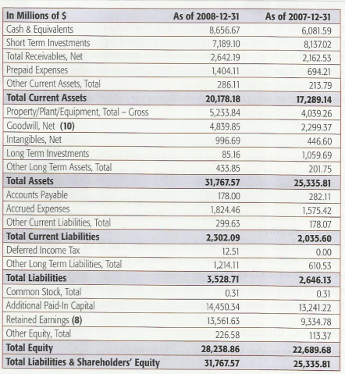
- All the money belonging to the company’s owners.
- Assets whose value can only be turned into cash with difficulty (e.g. reputation, patents, trade marks, etc.)
- Expenses such as wages, taxes and interest that have not yet been paid at the date of the balance sheet.
- Money owed by customers for goods or services purchased on credit.
- Money owed to supplies for purchases made on credit
- Cash flow statement contain three categories: Cash from Operating Activities (Ops.), Cash from Investing Activities (Inv.) and Cash from Financing Activities (Fin.). Which categories (Ops.; Inv.; or Fin.) do the following items belong to?
- Amortization (loss of value of intangible assets)
- Changes in the size of the inventory
- Dividends paid
- Proceeds from issuing shares or debt
- Purchases or sales of property, plant and equipment

QUESTION 4: Fill the gaps with words in the box below (2.5 Marks)
market capitalization | suppliers | synergy | undervalued
horizontal integration | diversification | asset-stripping | subsidiaries
distributors | vertical integration
(1)______ is when a company gets bigger by acquiring competitors in the same field of activity. (2)______ is acquiring companies involved in other parts of the supply chain, usually to make cost savings. There are two possibilities: backward integration is acquiring (3)______ of raw materials or components; forward integration is buying (4)_____ or retail outlets. Companies can also buy businesses in completely different fields, which is known as (5)_____. This can be done to reduce the risk involved in operating in only one industry – but taking part in completely different industries is a risk itself.
A series of takeovers can result in a conglomerate controlling a number of smaller companies that it owns, known as (6)_____. Takeovers do not always result in (7)_____ - combined production or productivity that is greater than the sum of separate parts. In fact, statistics show that most mergers & acquisitions reduce rather than increase a company’s value. An inefficient conglomerate whose profits are too low can have a low stock price, it’s (8)_____ - the total market price of all its ordinary shares - can fall below the value of its assets including land, buildings, etc. If this happens, it becomes profitable for another company to buy the conglomerate and either split it up and sell it as individual companies, or close the companies and sell the assets. This called (9)_____. It shows that stock markets are not always efficient, and that companies can sometimes be (10)_____.
** END OF THE TEST **
Module learning outcomes | Test questions
[G2.1] Expanding and improving knowledge in Banking & Finance such as stocks, bonds, accounting & financial statement, takeovers | Q1; Q2; Q3; Q4
[G3.2] Using accurate English terms in Banking & Finance. | Q1; Q2; Q3; Q4
[G4.1] Able to provide in-depth analysis in English that reflects the economic operations that arise in an enterprise | Q3; Q4
Ngày 21 tháng 07 năm 2020
Thông qua trưởng bộ môn

Nguyễn Thị Châu Long

Answer key
QUESTION 1. (2.5 Marks)
- Principal  - Credit rating  - Gilt-edged stock  - Default  - Maturity date | - Treasury bonds  - Coupon  - Treasury notes  - Yield  - insolvent

QUESTION 2. (2.5 Marks)

- ordinary shares
- preference shares
- fixed-dividend
- goes bankrupt
- goes into liquidation

- True
- True
- False
- True
- False
QUESTION 3: (2.5 Marks)
- Shareholders’ Equity  - Intangibles  - Accrued Expenses  - Total Receivables  - Account Payable | - Opt.  - Opt.  - Fin.  - Fin.  - Inv.

QUESTION 4: (2.5 Marks)

- Horizontal integration  - Vertical integration  - Suppliers  - Distributors  - Diversification | - Subsidiaries  - Synergy  - Market capitalization  - Asset-stripping  - Undervalued

